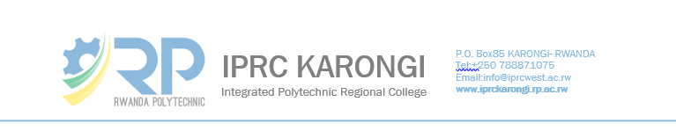

**TIME TABLE OF EXAMS SEMESTER 1 2021**

**ICT DEPARTMENT**

**Year III IT {C}**

|  |  |  |  |  |  |
| --- | --- | --- | --- | --- | --- |
| **LEVEL 3 (Year III)** | | | | | |
| **FROM 28/06 – 02/07/2021** | | | | | |
| **Time** | **Monday**  **28/06/2021** | **Tuesday**  **29/06/2021** | **Wednesday 30/06/2021** | **Thursday**  **1/07/2021** | **Friday**  **02/07/2021** |
| 8:00- 10:00 |  |  |  |  |  |
| 14:00- 16:00 |  | N. Gabriel  Venue: Room 4 (NY |  |  | M. Joseph  Venue: Room 4 (NY |

|  |  |  |  |  |  |
| --- | --- | --- | --- | --- | --- |
| **FROM 05/07 – 09/07/2021** | | | | | |
| **Time** | **Monday**  **5/07/2021** | **Tuesday**  **06/07 /2021** | **Wednesday**  **07 /07 /2021** | **Thursday**  **08/07 /2021** | **Friday**  **09 /07 /2021** |
| 8:00- 10:00 |  |  |  |  |  |
| 14:00- 16:00 |  | K. Emile  Venue: Room 4 (NY |  |  | N. Gabriel  Venue: Room 4 (NY |